# Lab11: Dropbox Creation and Usage

Step1: Create the s3 bucket

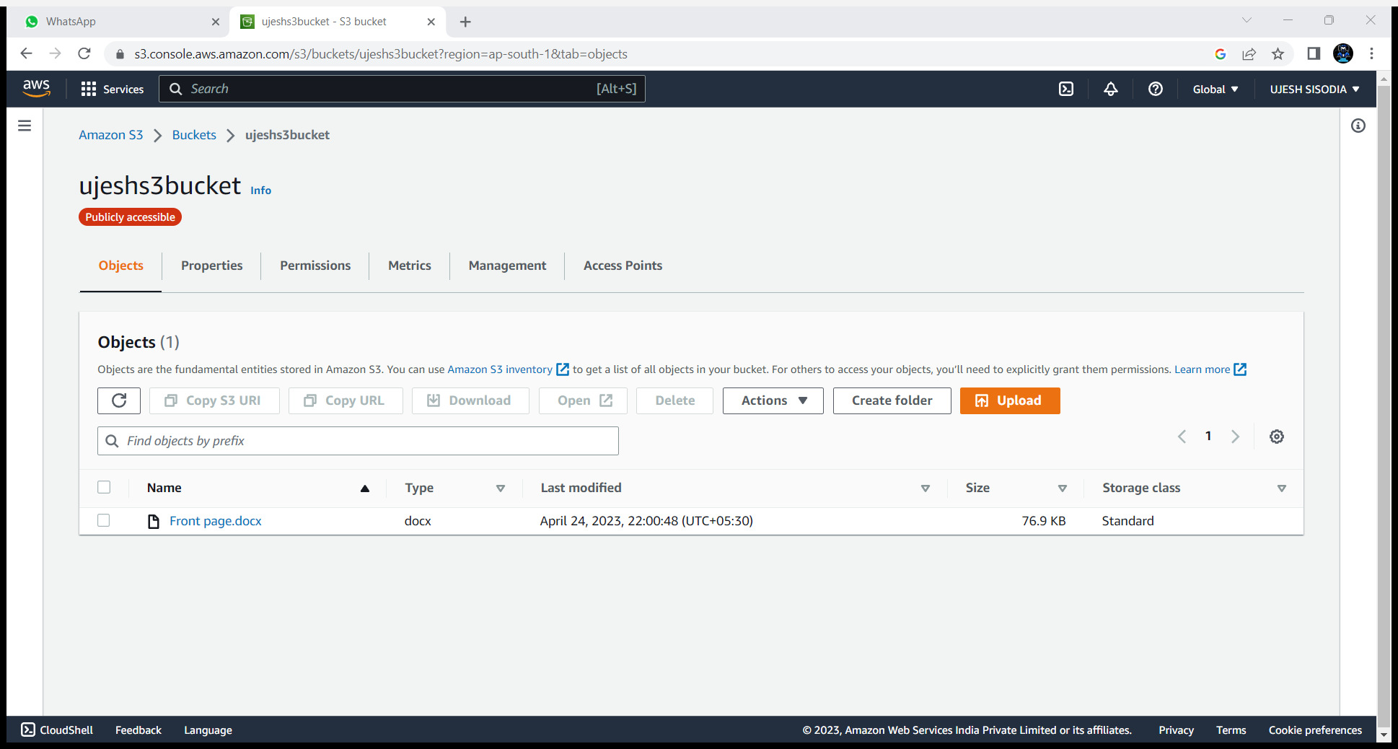

Step2: configure the aws with cmd in your pc by giving access key id and secret access key in command -> aws configure

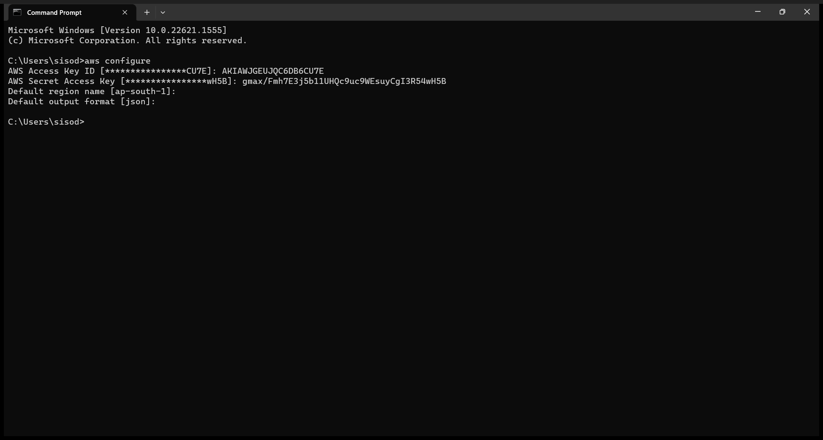

Step3: now check whether its is working by listing bucket name of aws by command->aws s3 ls

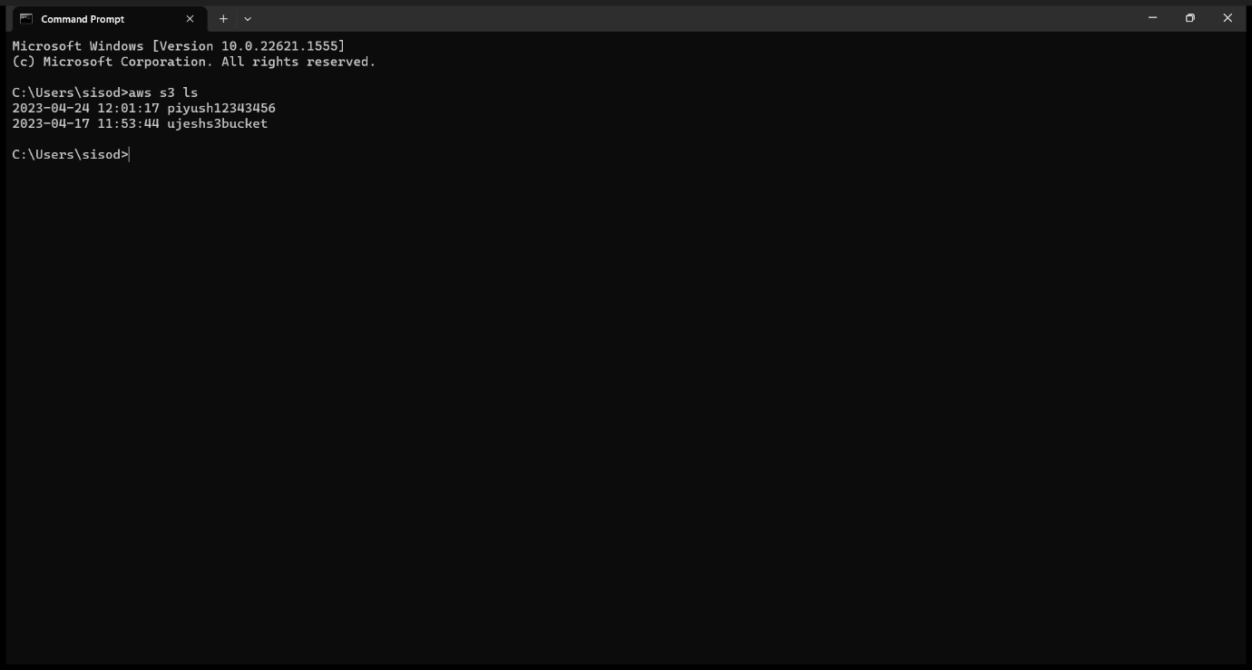

Step4: now see the name of objects uploaded by the command-> aws s3 ls s3://priyanshubucket43

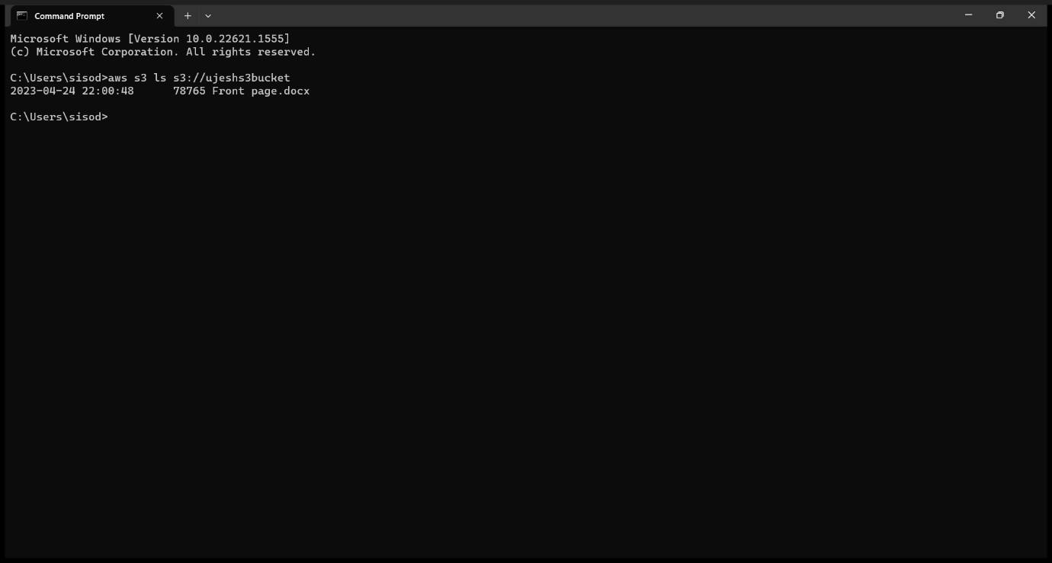

Step5: now copy the file in the aws bucket by command->aws s3 cp "C:\Sem 4\cca\LAB-5.docx" s3://priyanshubucket43

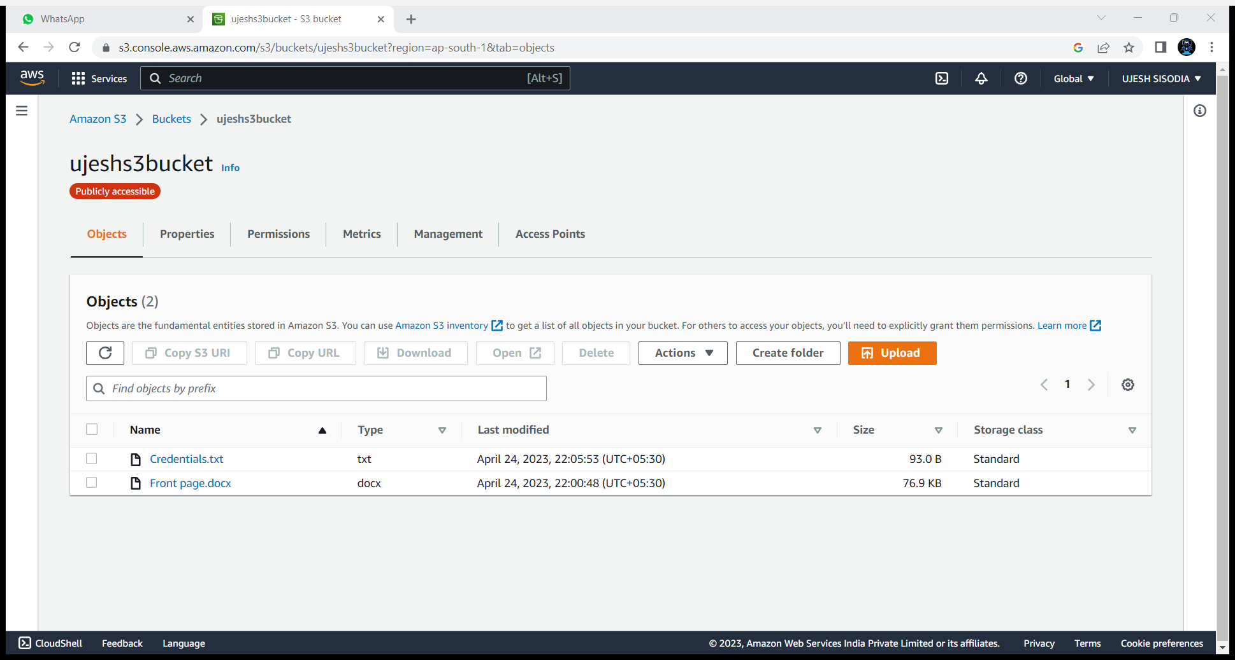

Step6: now copy the folder by command->aws s3 sync "C:\Sem 4\cca" s3://priyanshubucket43

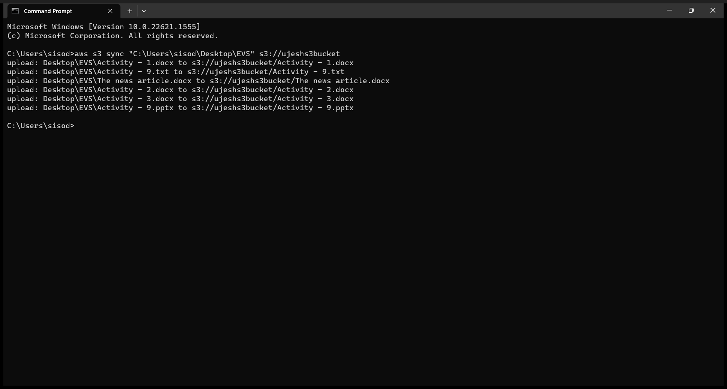

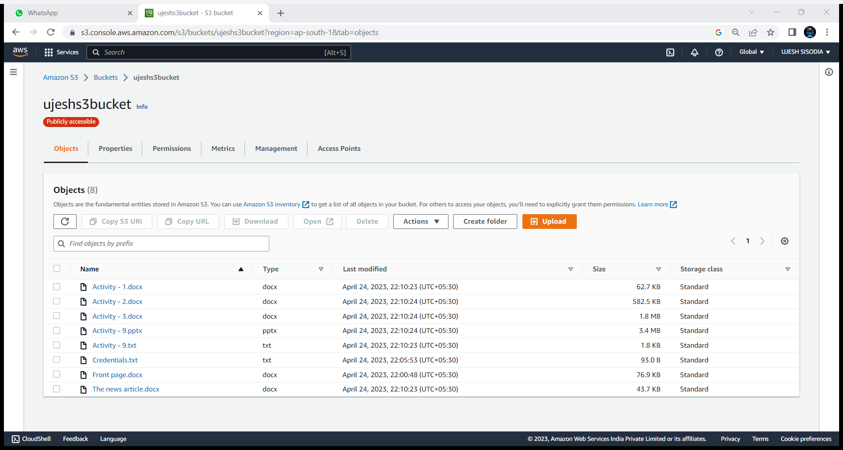

Task2: now copy the folder by the help of task schedular

Step7: create and save two files with txt and bat extension

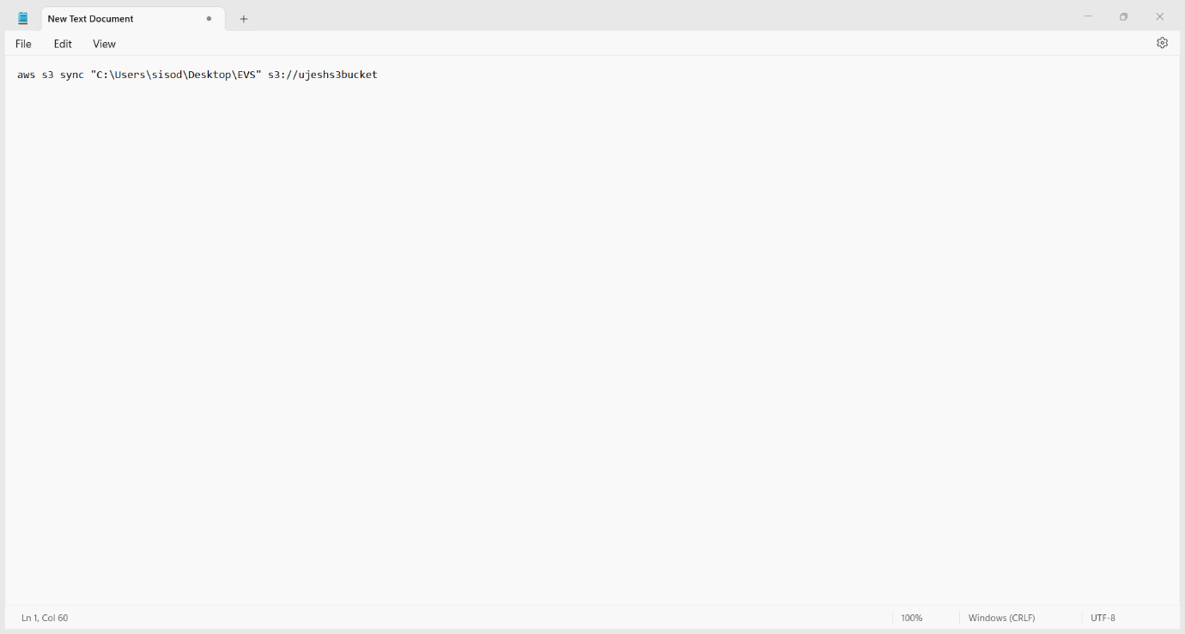

Step8: now open task schedular

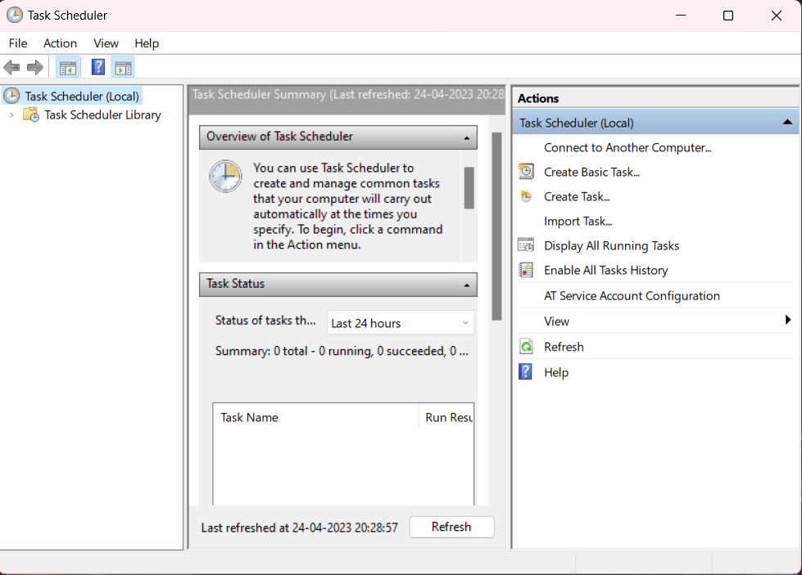

Step9: now click on create task and provide name to task

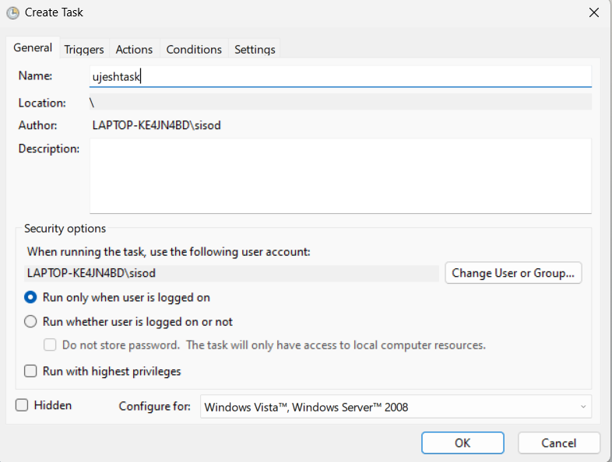

Step 10: now trigger the time of running of the ujeshtask

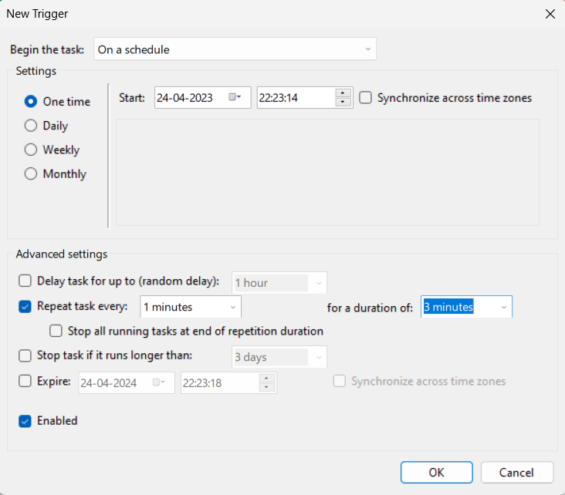

Step 11: now on actions mention the bat file

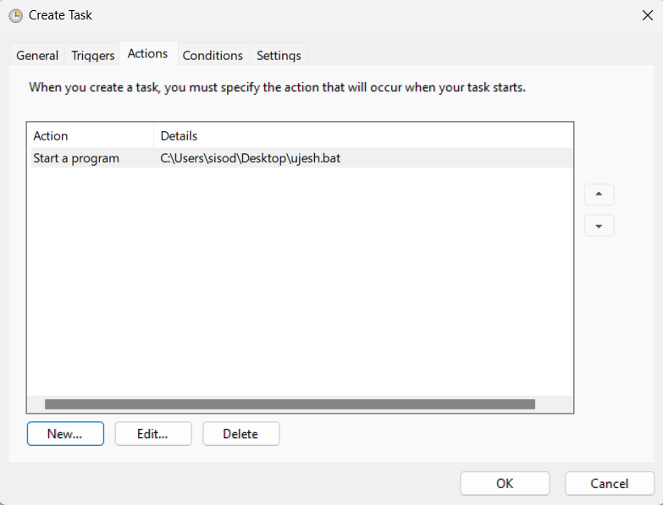

Step 12: now the task will start showing the screen like below every time till the time of running ran out

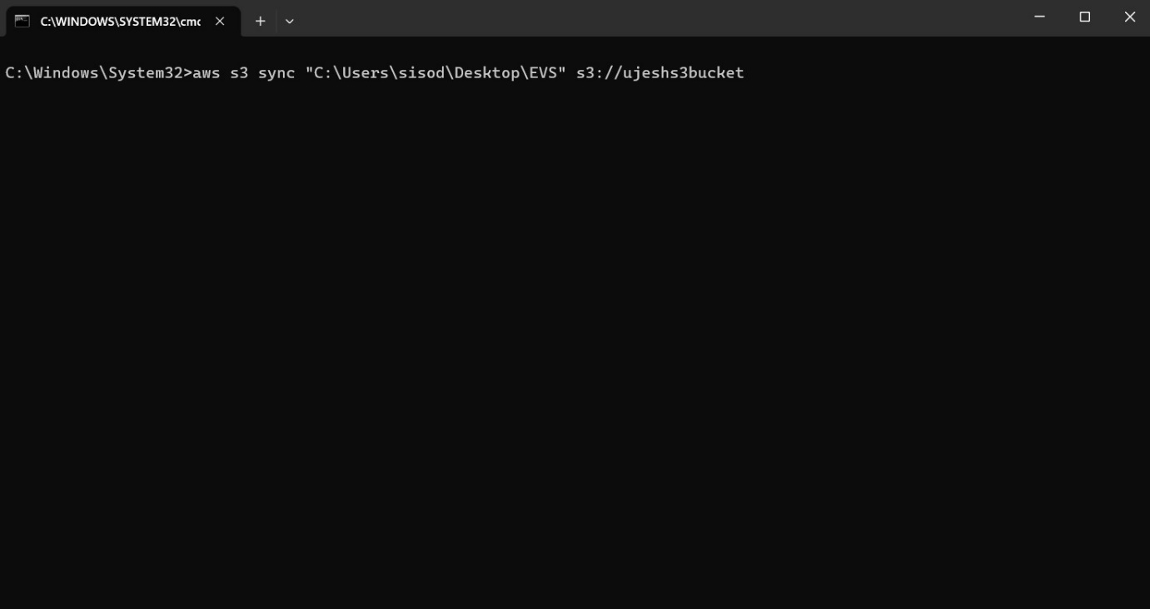

Step 13: hence file of robotics is successfully uploaded in your s3 bucket

